Internet Protocols Final Exam Solutions
2016. 6. 15

- Suppose OSPF computes the routing table for the following network topology. What will go into the ‘Next Hop’ column in the routing table at router “w”? Fill in the empty boxes in the table. [10pts]
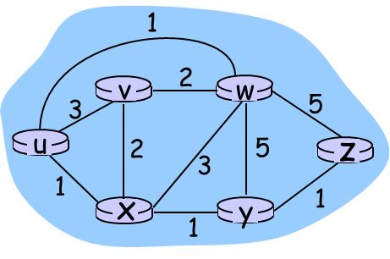
Destination | Next Hop
u | u
v | v
x | u
y | u
z | u

- The following is a part of an email header. Answer the following questions about the header.
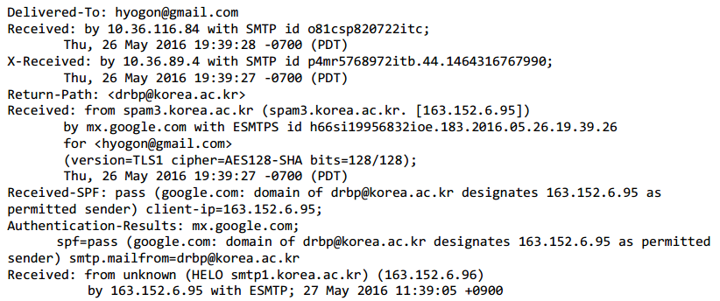
  - How many mail servers are involved in this mail delivery? ______5_____[3pts]
  - We can see that the Google mail server (mx.google.com) checks if 163.152.6.95 is indeed a mail server address for korea.ac.kr domain. What resource record (RR) type is used in this checking? _____txt_______[3pts]
  - Among the three variants of STMP used in the conversations between mail servers, which do you think involves secure conversation? __ESMTPS_______ (Hint: TLS = Transport Layer Security, AES = Advanced Encryption Standard, SHA = Secure Hash Algorithm). [2pts]
  - What is the time difference between the Korea University mail servers and the Google’s mail servers? _______16 (hours)___________ [3pts]

- Another part of the same email is shown below. Answer the following questions.
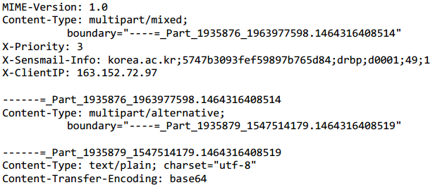
  - Based on the Content-Type and the boundary string, at least how many “atomic” parts can you expect to see in the mail body? _______3_____ [4pts]
  - This mail contains Korean characters. What keyword in the header most strongly signals it? _____base64___________ [4pts]
- What is the difference between a stub AS and a multi-homed AS? [5pts]
A multi-homed AS has more than 1 connection to other AS’s, whereas a stub AS has only 1.
- ASCII code of ‘A’ is 65 in decimal, ‘B’ is 66, ‘C’ is 67, …, and ‘Z’ is 90. A Base64 encoded string is U1VNTUVS. What was the original ASCII string before it was encoded in Base64? ___SUMMER__(note: all capital)_______ [10pts]
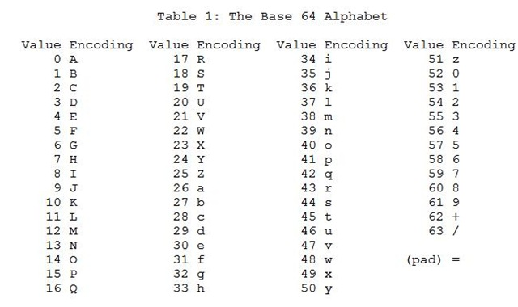
- The following shows how you use telnet command to connect to the POP3 server at mail.korea.ac.kr to retrieve emails if any. (It turns out that there is no mail waiting for you there.) Suppose your username is obama and the password is putin. Fill the four empty lines. [8pts]
C:\Users\obama> ________telnet mail.korea.ac.kr 110______
+OK SensMail 8.0 POP3 service ready. <1402932554133.1234@mail.korea.ac.kr>
______user obama_______________________________________
+OK Password required for messi@korea.ac.kr
______ pass putin _______________________________________
+OK Maildrop has 0 messages (0 bytes)
______ quit_______________________________________
+OK Sensmail POP3 service closing session
C:\Users\obama>
Connection closed.
- In the following AS graph, if only the local preference and the multi-exit descriptors are used to find the best path, what will be the result of a traceroute (tracert) from Hillary to Bernie? Write down the sequence of routers as they appear in the output. _____(Hillary) A D G I K L (Bernie)___ [10pts]
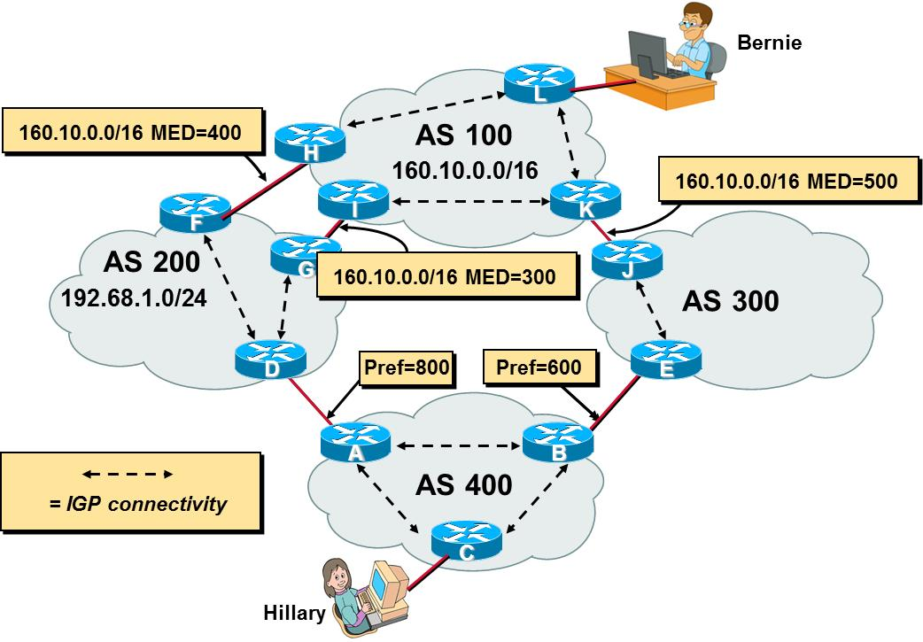

- The following figure shows that AS 500 has four entries in its BGP table that correspond to the prefixes of AS 100, 200, 300, and 400. Fill in the BGP table of AS 400. [8pts]
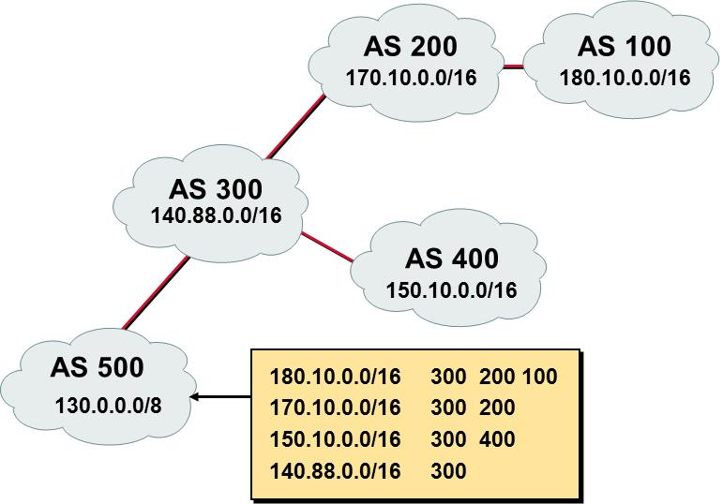
180.10.0.0/16 300 200 100
170.10.0.0/16 300 200
140.88.0.0/16 300

----------------- Review questions from Midterm #1/2/3 ---------------------------

- Suppose an IP datagram arrives at a computer that has two interfaces whose IP addresses are 163.152.161.2 and 10.16.10.3, respectively. Now, the datagram has destination address 121.129.49.80, and the computer is configured to function as a router. If the routing table at the computer is as shown below,
Destination Netmask Gateway Interface Metric
0.0.0.0 0.0.0.0 163.152.161.1 163.152.161.2 20
0.0.0.0 0.0.0.0 10.16.10.1 10.16.10.3 25
10.16.10.0 255.255.255.0 Connected 10.16.10.3 281
10.16.10.167 255.255.255.255 Connected 10.16.10.3 281
10.16.10.255 255.255.255.255 Connected 10.16.10.3 281
127.0.0.0 255.0.0.0 Connected 127.0.0.1 306
127.0.0.1 255.255.255.255 Connected 127.0.0.1 306
127.255.255.255 255.255.255.255 Connected 127.0.0.1 306
163.152.161.0 255.255.255.0 Connected 163.152.161.2 266
163.152.161.54 255.255.255.255 Connected 163.152.161.2 266
163.152.161.255 255.255.255.255 Connected 163.152.161.2 266
255.255.255.255 255.255.255.255 Connected 127.0.0.1 306
255.255.255.255 255.255.255.255 Connected 163.152.161.2 266
255.255.255.255 255.255.255.255 Connected 169.254.195.4 286
255.255.255.255 255.255.255.255 Connected 10.16.10.167 281
  - How many matching entries are there for the arriving packet? [3pts]
2
  - What will be the destination address in the datalink layer header if the ARP cache is as given below? [3pts]
64-ae-0c-41-32-c0
121.129.49.81 | 64-ae-0c-41-32-c0 | dynamic
163.152.161.1 | 64-ae-0c-41-32-c0 | dynamic
10.16.10.1 | f8-66-f2-7d-99-ff | dynamic
255.255.255.255 | ff-ff-ff-ff-ff-ff | static

  - If you perform a limited broadcast, what interface will the packet go out on? (Identify the IP address of the interface) [3pts]
163.152.161.2
- Suppose a table in a SNMP agent has the following structure.
130 | 1 | 130
130 | 2 | 130
89 | 1 | 1600
92 | 2 | 444
93 | 1 | 1600
92 | 1 | 1600

  - Which should be the index column(s)? [3pts]
1 & 2
  - If the OID of the table is .1.3.6.1.2.1.2.2 and the OID of the table entry is .1.3.6.1.2.1.2.2.1, what would be the OID of the value 444 in the table? [3pts]
.1.3.6.1.2.1.2.2.1.3.92.2
- In the following IGMPv2 trace that is captured at a set-top box for Korea Telecom’s IPTV,
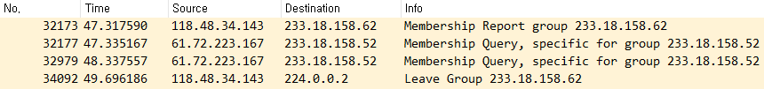
  - What is the IP address of the IGMP speaker that is a member of 224.0.0.1 but not 224.0.0.2? ___118.48.34.143_________ [3pts]
  - What group did the set-top box newly join? ___233.18.158.62________ [3pts]

- The following TCP trace shows the last part of a connection.
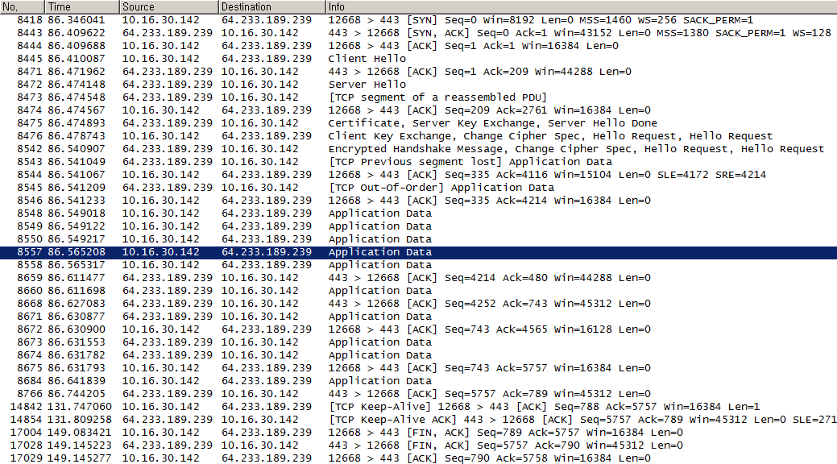
  - What MSS would this connection use for the data exchange? ____1380____ [3pts]
  - How many data bytes did this connection transport from 10.16.30.142 to 64.233.189.239? __________788___________________[3pts]
  - How many data bytes did this connection transport from 64.233.189.239 to 10.16.30.142? ____________5756___________________[3pts]

