Internet Protocol Term Project:
SNMPv2 client implementation as an Android application

- Programming environments
- Android ( JAVA, no JNI )
  - Specify the Android version on your report
- A SNMP server agent (a networked camera) will be provided on the network for the functional testing of your application
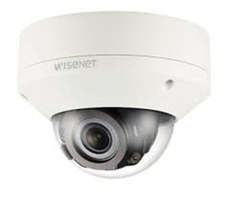
- Use of SNMP4j (or any) library is not allowed
  - But for the BER encoder part, you will be provided with a source code
  - You can refer to the SNMPj4 library, but Copy & Paste is not allowed
(or 0 points will be given for the implementation )
- Functions to be implemented on the client application
  - Snmpget: retrieve the value of a managed object using SNMP GET message
  - Snmpset: sets the value of a managed object using SNMP SET message
  - Snmpwalk: retrieve a subtree of managed objects using SNMP GETNEXT message
  - Input and output interfaces

- SNMP server agent information
- Host name: kuwiden.iptime.org
- Port: 11161
- Community string for read operation: public
- Community string for write operation: write

- Report
  - SNMPv2 packet format description
  - Descriptions of how you make, send, receive, and parse a SNMPv2 packet
    - Discuss here any problems, solutions to the problems, and references you used, etc.
    - If there is no mention of the references you used, it will be regarded as cheating.
  - Descriptions of the environments, classes, and application call flow
  - Comments in each Class, Function, Thread, etc. of your source code
  - Image capture of the functional testing of get, set, and walk
    - Describe what’s happening in the image capture
    - In case of snmpwalk, make a log file that shows all traversed MIB table entries and their values

- Evaluation
  - Scoring will be based on the report.

- Android application example
  - The following is just an example. You can freely design the screen. But,
  - It should be able to receive OIDs, VALUEs, and functions as inputs.
  - It should print results of function execution to the screen.

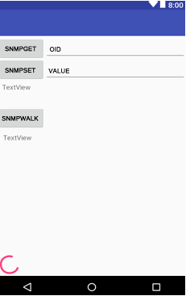

- Functional testing example (on Linux) - FYI
  - snmpget
  - snmpset
  - snmpwalk
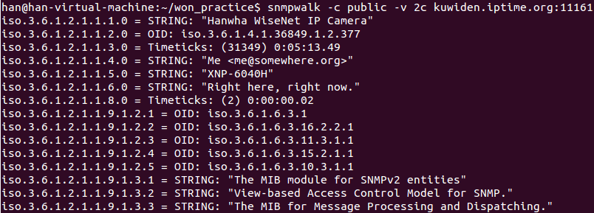

- Submit your source code to Blackboard.
  - File name format: StudentNumber_Name.zip, StudentNumber_Name.docx
  - Upload the source code and the report to “Assignments” on the Blackboard system.
  - Follow these steps:
    - Step1: Log in https://kulms.korea.ac.kr/

    - Step2:
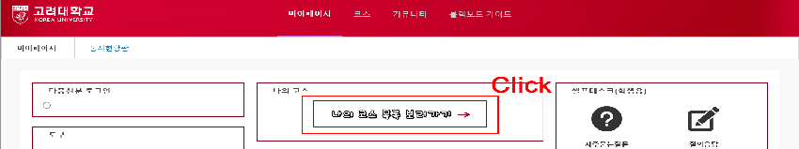
    - Step3:
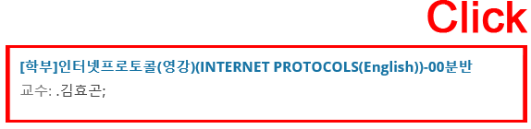
    - Step4:
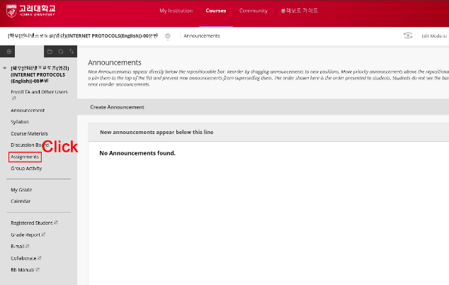
    - Step5:
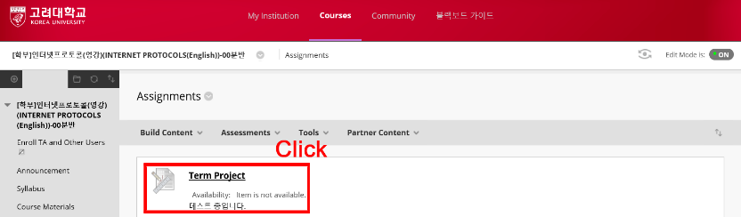
    - Step6:
