Internet Protocols Final Exam

Name ________________________ Student ID _____________________

- What is the purpose of the gratuitous ARP packets in the following trace? [5pts]
Duplicate address detection (DAD)

- When would my PC first try to renew the lease according to the ipconfig output? [5pts]

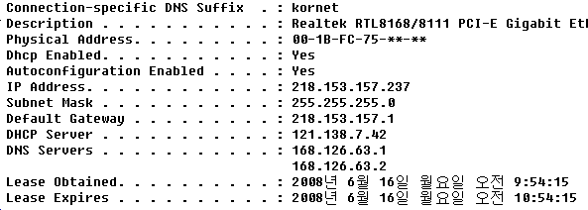

Translation ☞ 월=Month, 일=Date, 월요일=Monday, 오전=A.M.
2008년 6월 16일 오전 10:24:15 (10:24:15 A.M. on 6/16/2008)

- In Problem 2, where is the BOOTP Relay located? [5pts]
218.153.157.1

- Although most IP options are useless today, IGMP v2 uses so called the Router Alert (RA) option as shown in the packet capture. With this option, the IP (multicast) router must look for the IGMP packet in the datagram. Why would you think the option is convenient? (Hint: consider the difference between simply forwarding an IP datagram destined to a multicast address and processing IGMP packet?) [10pts]
It can be used to force the router to process the IGMP message in the payload of an IP datagram; for multicast data packets the option does not have to be used since the router can forward them by just looking at the IP header.
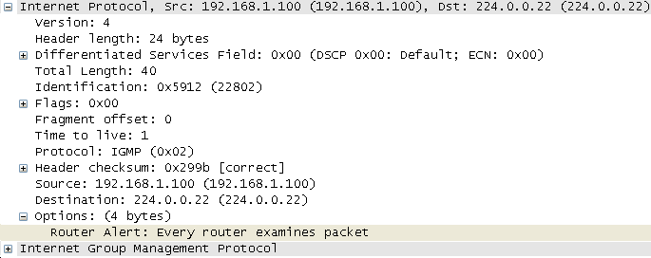

- In the following Wireshark capture, where do you think that the Nagle’s Algorithm is achieving its intended purpose? Identify the data packet numbers [5pts] and explain why you think so [5pts].
Packets #48, #54 --- these are carrying more than 1 byte

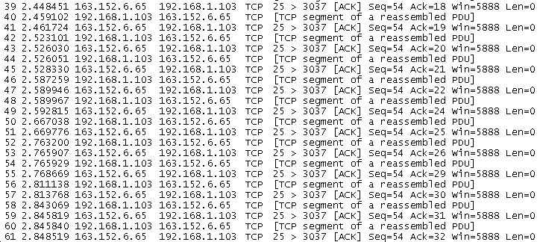

- What is the base-64 encoding of 01010000 10111111 00100011 ? [5pts]
00010100 00001011 00111100 00100011

- What are the three pieces of information that must be “synchronized” upon TCP connection setup? [6pts]
Initial sequence number (ISN)
Maximum segment size (MSS)
Window size (or the availability at the receive socket buffer)

- Suppose you are a mail server named bluehouse.go.kr. After connecting to mailhub-wh3.whitehouse.gov at TCP port 25, you want to deliver an email from mb@bluehouse.go.kr to obama@whitehouse.gov. Write down the SMTP commands and data in correct sequence to achieve the delivery of the email message, “I love soccer.” [10pts]
HELO bluehouse.go.kr
MAIL FROM: mb@bluehouse.go.kr
RCPT TO: obama@whitehouse.gov
DATA
I love soccer.
.
QUIT

- In Problem 8, why would we need a separate protocol to deliver an email from mailhub-wh3.whitehous.gov to President Obama’s computer? Why can’t we just use SMTP?

- Most SNMP messages carry name-value pairs. What is the SMI type of the name? [5pts]
OBJECT IDENTIFIER

- Suppose your side of TCP sent a SYN segment with a Window Scale option. Now you look for the Window Scale option in the arriving SYN/ACK segment from the peer TCP. How is the TCP Window Scale option being set to 0 (e.g. as in Problem 5) different from the option not being used? [10pts]
Window Scale 0 means that the TCP peer understands the other’s WS option, but that it won’t scale its own window advertisement; no Window Scale option means the option shall not be used for the connection at all.

- I got the following responses from a mail server at Gmail (Google mail). See that the server recognizes VRFY command, but it effectively declines to confirm if the account (i.e., hyogon) exists. What do you think is the reason? [10pts]
Not allowing spammers to confirm and collect valid email addresses from this mail server.

220 mx.google.com ESMTP k1si6320910ybe.115
EHLO babo.net
250-mx.google.com at your service, [218.153.157.211]
250-SIZE 35651584
250-8BITMIME
250 ENHANCEDSTATUSCODES
VRFY hyogon@gmail.com
252 2.1.5 Send some mail, I'll try my best k1si6320910ybe.115

- Suppose a network management system (NMS) wants to read the following table at a managed device, and the OID of a row in the table is X, and columns 1 and 2 are used as the index.
  - In order to get the value at position [3,3] (i.e., “37”), what OID instance should the NMS specify? [5pts]
X.3.2.7

  - If the NMS issues the getnext of [2,2], what value does it get? [5pts]

5 (In lexicographic order, the ‘next’ of X.2.7.2 is X.3.1.2, whose value is 5)

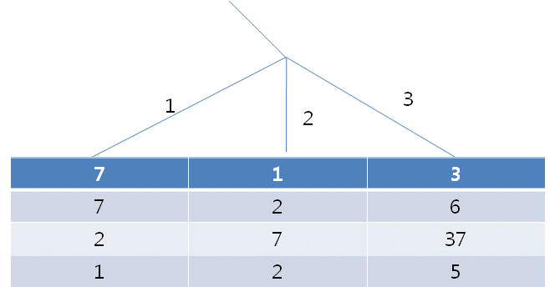
- Although not shown in the following packet sequence, there should be a query to DNS before the first packet (#17). What query type would it have? [4pts]
MX

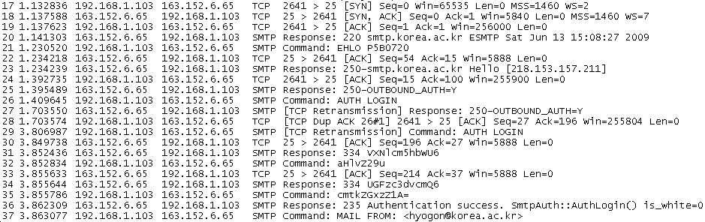

- In UDP, a datagram destined to a port number for which there is no running process triggers the transmission of an ICMP destination (port) unreachable error. What happens if a TCP segment is sent to a port number that does not have a running process? [5pts]
TCP Reset segment is sent in response.

